

SERIAL COMMUNICATION

NO. | MATRIC NO. | NAME
1 | 2416289 | MUHAMMAD IRFAN HAKIMI BIN MOHD RIZUAN
2 | 2128653 | MUHAMMAD NAJMI BIN MOHD AZAM
3 | 2120279 | MUHAMMAD SHAHABUDIN BIN ISHAK

TABLE OF CONTENTS
INTRODUCTION 2
MATERIALS AND EQUIPMENT 2
EXPERIMENTAL SETUP 3
METHODOLOGY 4
Arduino code 4
Python code 5
RESULTS 6
DISCUSSION 6
ACKNOWLEDGEMENT 7
STUDENT'S DECLARATION 7

INTRODUCTION
The objective of this experiment is to exchange data between a computer and a microcontroller by using the potentiometer and LED . By sending the potentiometer readings from Arduino to a Python script through a USB connection, we will be able to understand how it exchanges data with the code that uploads in the microcontroller.

MATERIALS AND EQUIPMENT
The following components were utilized during the experiment:
- Arduino Uno board
- Potentiometer
- LED
- Jumper wires
- Breadboard

EXPERIMENTAL SETUP
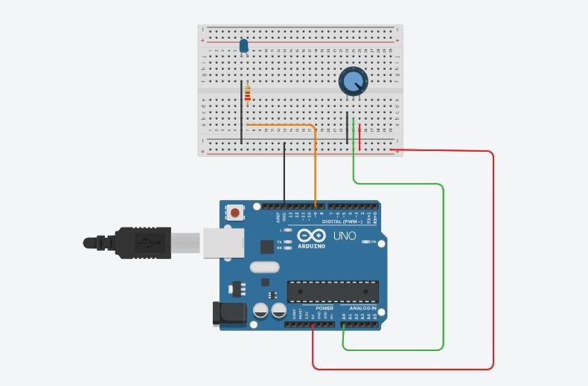
Here are the steps of equipment and components that were set up for the experiment:
- 5V on the Arduino was connected to one leg of the potentiometer.
- GND on the Arduino was connected to the other leg of the potentiometer.
- An analog input pin on the Arduino was connected to the middle leg(wiper) of the potentiometer
- The LED was connected to the Arduino by attaching the longer leg (anode,+) to one end of the resistor, and the shorter leg (cathode,-) to the GND pin.
- A resistor was used for the LED by connecting one end of the resistor to digital pin, and other end to the longer leg of LED

METHODOLOGY

- Connect the Arduino to your computer via a USB cable
- Power ON the Arduino
- Run the python script on your computer
- As you turn the potentiometer knob, you should see the potentiometer readings displayed in the Python terminal
- You can use these readings for various experiments, data logging, or control applications
- Open the Serial Plotter; in the Arduino, go to “Tools” > “Serial Plotter”
- Select the correct COM port
- Set the Baud Rate: ensure that the baud rate in the Serial Plotter matches the one set in Arduino code
- Read real-time data with the potentiometer knob and the Serial Plotter will display the potentiometer readings in real-time, creating a graphical representation of the data. You can see how the values change as you adjust the potentiometer.
- Customize the Plotter by adjusting settings such as the graph range, labels, and colors.

Arduino code


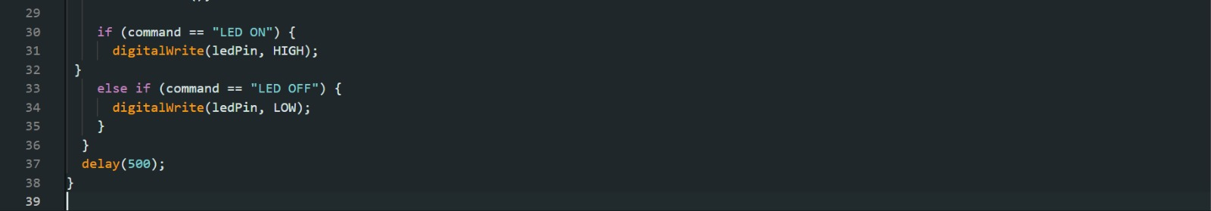

Python code
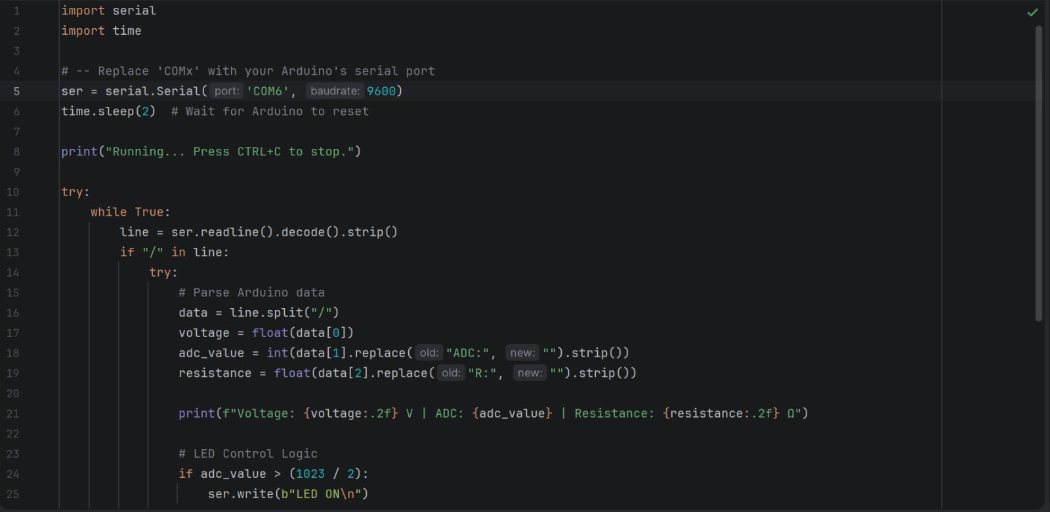



RESULTS
The experiment successfully demonstrated real-time data transmission between the Arduino and the Serial Plotter. As the potentiometer was rotated, corresponding changes in ADC values were displayed graphically. The plotted data confirmed a predictable, smooth increase in ADC values, aligning with expectations based on the potentiometer’s behaviour. The ADC values range from approximately 80 to 220, showing a controlled variation based on potentiometer rotation. The data followed a consistent trend with occasional flat segments where the potentiometer remained in a fixed position. No significant fluctuations or signal noise were observed, indicating a stable connection and reliable data transmission. These results confirm that the Arduino effectively reads and transmits potentiometer values over serial communication.

DISCUSSION
The expected and observed outcome are both the same result. There are no discrepancies between expected and observed outcome because the experiment successfully demonstrated real-time data transmission between the Arduino and the Serial Plotter.
One of the potential limitations that were mentioned is the narrow range of ADC values that were recorded. Instead of operating in the full range, the output of the potentiometer remained in a small window. This could be due to the potentiometer calibrating the potentiometer to produce full-range outputs.
In addition, the Serial Plotter provided a useful real-time plot. To have a Python script to record the values into a file for more detailed post-analysis would increase the experiment analytical capability.
Potential sources of inaccuracy are minor ADC values variations due to electrical noise, resistance changes in the potentiometer, or instability of manual adjustments. However, the overall trend shows that the Arduino’s ADC is functioning as expected and accuratly displays the potentiometer’s voltage output.

ACKNOWLEDGEMENT
We would like to express our deepest appreciation to our instructor, Assoc. Prof. Eur. Ing. Ir. Ts. Gs. Inv. Dr. Zulkifli Bin Zainal Abidin, for his invaluable guidance, continuous support, and constructive feedback throughout the completion of this project. His expertise and dedication have been instrumental in deepening my practical and theoretical understanding of mechatronics engineering. Furthermore, we are grateful to the Department of Mechatronics Engineering at the International Islamic University Malaysia for providing the necessary laboratory facilities and a conducive environment that made this work possible.

STUDENT'S DECLARATION
We hereby declare that the work presented in this technical report is entirely our own, except where explicitly acknowledged. We certify that in developing and completing this mechatronics project, we have strictly adhered to the standards of academic integrity and have not engaged in any form of plagiarism or unethical conduct. All sources of information, reference materials, and technical support utilized in this work have been appropriately cited and acknowledged.

Certificate of Originality and Authenticity

This is to certify that we are responsible for the work submitted in this report, that the original work is our own except as specified in the references and acknowledgment, and that the original work contained herein has not been untaken or done by unspecified sources or persons. We hereby certify that this report has not been done by only one individual, and all of us have contributed to the report. The length of contribution to the reports by each individual is noted within this certificate. We also hereby certify that we have read and understand the content of the total report, and no further improvement on the reports is needed from any of the individual contributors to the report. We therefore agreed unanimously that this report shall be submitted for marking, and this final printed report has been verified by us.

Signature: IrfanHakimi Read[/]
Understand[/]
Name: Muhammad Irfan Hakimi Bin Mohd Rizuan Agree[/]
Matric : 2416289

Signature: Najmi Read[/]
Understand[/]
Name: Muhammad Najmi Bin Mohd Azam Agree[/]
Matric : 2128653

Signature: Shahabudin Read[/]
Understand[/]
Name: Muhammad Shahabudin bin Ishak Agree[/]
Matric : 2120279

